**Consumer Financial Protection Bureau (CFPB)**

The Consumer Financial Protection Bureau (CFPB) is an independent agency of the United States government responsible for regulating consumer protection in the financial sector. It was established as a response to the financial crisis of 2007-2008 and the subsequent recession.

**Key Functions of the CFPB**

Regulating Financial Products and Services:

Enforcing Consumer Protection Laws:

Educating Consumers:.

Handling Consumer Complaints:

Research and Analysis:

Supervising Financial Institutions:

**Historical Context and Purpose**

**Response to Financial Crisis**:

The CFPB was created in response to the financial crisis of 2007-2008, which highlighted significant gaps in consumer protection in the financial sector.

Many consumers were adversely affected by unfair and deceptive practices, particularly in the mortgage market.

**Dodd-Frank Act**:

The CFPB was established under the Dodd-Frank Wall Street Reform and Consumer Protection Act of 2010.

The Act aimed to prevent another financial crisis and protect consumers by increasing transparency and accountability in the financial system.

**Structure and Independence**

Director and Leadership:

Funding and Independence:

**Key Achievements and Impact**

Consumer Redress and Penalties:

Improving Financial Literacy:

Policy Development:

**The CFPB is standing up for you**

4 million+ consumer complaints received responses

$20.7 billion+ in financial relief as a result of CFPB actions

205 million+ people eligible for financial relief

**Protecting you from junk fees**

The CFPB is working to save households billions of dollars a year by reducing exploitative junk fees charged by banks and financial companies.

**Credit card key terms**

Credit invisible

Credit reporting company

Credit report

Credit score

Fair Credit Reporting Act

Fraud alert

Identity theft

Military active duty alert

Security freeze

Specialty consumer reporting company

Tenant screening report

Thin credit file / No credit files

**Debt collection Key terms**

Credit counselor

Debt Collection Rule

Debt collector

Fair Debt Collection Practices Act (FDCPA)

Garnishment

Harassment by a debt collector

Judgment

Limited-Content Message

Original creditor

Statute of limitations

Validation Notice

**Mortgage loans Key terms**

Automatic payment

Bi-weekly payment

Delinquent

Escrow

Force-placed insurance

Forbearance

Foreclosure

Loan modification

Loss mitigation

Refinance

Reverse mortgage

Servicer

**Credit card key terms**

Annual Percentage Rate (APR)

Balance transfer

Credit balance

Daily periodic rate

Grace period

Interest rate

Prescreened credit card offer

Unauthorized use

**AMLA- Anti money laundering act**

Anti-Money Laundering (AML) in U.S. Banking Systems

Anti-Money Laundering (AML) regulations in the U.S. banking system are designed to prevent illicit financial activities such as money laundering and terrorist financing. Key components of AML compliance include:

**Bank Secrecy Act (BSA):**

Enacted in 1970, the BSA requires financial institutions to keep records and file reports on certain financial transactions.

Reports include Currency Transaction Reports (CTRs) for transactions over $10,000 and Suspicious Activity Reports (SARs) for suspicious activities.

**USA PATRIOT Act:**

Enacted in 2001, it enhances the BSA by requiring stronger verification of customers’ identities and more rigorous monitoring of financial activities.

Financial institutions must implement Customer Identification Programs (CIP) to verify the identity of individuals and entities opening accounts.

**Customer Due Diligence (CDD) and Enhanced Due Diligence (EDD**):

CDD involves understanding the nature and purpose of customer relationships to develop risk profiles.EDD applies to high-risk customers, requiring more detailed information and continuous monitoring.

**Transaction Monitoring**:

Banks use automated systems to monitor transactions for unusual patterns that may indicate money laundering.

Activities such as large cash deposits, rapid movement of funds, and transactions with high-risk countries are closely scrutinized.

**Suspicious Activity Reporting:**

Banks are required to file SARs with the Financial Crimes Enforcement Network (FinCEN) when they detect potentially suspicious activities.

SARs include details about the nature of the suspicious activity, the parties involved, and the amounts in question.

**AML Compliance Programs:**

Financial institutions must develop and maintain robust AML programs, which include written policies, procedures, and controls.

Regular training for employees on AML regulations and suspicious activity detection is essential.

Independent audits are conducted to ensure the effectiveness of the AML program.

**KYC -knowing your customer**

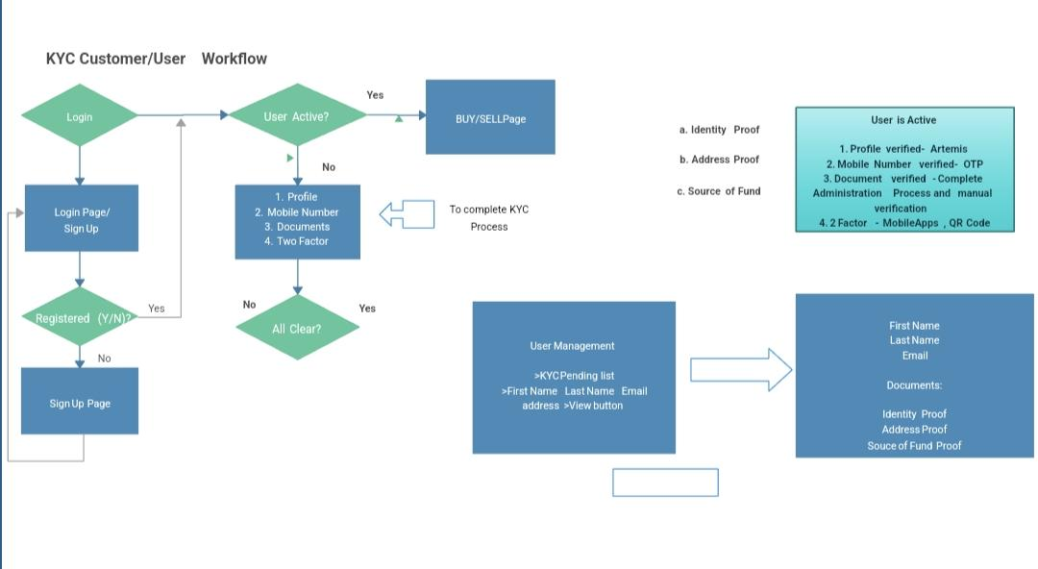

KYC (Know Your Customer) procedures in the U.S. banking system are designed to prevent money laundering, fraud, and other financial crimes. Here’s a detailed overview of the KYC process, including its key steps and components:

### Key Steps in the KYC Process

What Is Know Your Client (KYC)?

Know Your Client (KYC) is a standard in the investment industry that ensures advisors can verify a client’s identity and know their client’s investment knowledge and financial profile.

Three components of KYC include the customer identification program (CIP), imposed under the USA PATRIOT Act in 2001, customer due diligence (CDD), and ongoing monitoring or enhanced due diligence (EDD) of a customer’s account once it is established.

KEY TAKEAWAYS

Know Your Client (KYC) is a standard used in the investment and financial services industry to verify customers and know their risk and financial profiles.

Three components of KYC include the customer identification program (CIP), customer due diligence (CDD), and enhanced due diligence (EDD).

The SEC requires that each new customer provide detailed financial information before opening an investment or banking account

**Understanding Know Your Client (KYC**)

The Know Your Client (KYC) rule is an ethical requirement for those in the securities industry dealing with customers during the opening and ongoing maintenance of accounts.

KYC Requirements

**Customer Identification Program**

CIP requires that financial firms obtain four pieces of identifying information about a client, including name, date of birth, address, and identification number.

**Customer Due Diligence**

CDD is a process in which all of a customer’s credentials are collected to verify their identity and evaluate their risk profile for suspicious account activity.

**Enhanced Due Diligence**

EDD is used for customers that are at a higher risk of infiltration, terrorism financing, or money laundering and additional

**Different between AML ACT and KYC**

While both AML (Anti-Money Laundering) and KYC (Know Your Customer) are crucial elements in the regulatory framework designed to prevent financial crimes, they serve different purposes and have distinct components.

Aspect AML (Anti-Money Laundering) KYC (Know Your Customer)

Purpose Prevent and detect money laundering, terrorist financing, and other financial crimes. Verify the identity of customers to prevent fraud and ensure legitimate transactions.

Scope Broader regulatory framework encompassing various measures, including KYC. Specific component within the AML framework focusing on customer identity verification.

|  |  |  |
| --- | --- | --- |
| Aspect | AML (Anti-Money Laundering) | KYC (Know Your Customer) |
| Purpose | Prevent and detect money laundering, terrorist financing, and other financial crimes. | Verify the identity of customers to prevent fraud and ensure legitimate transactions. |
| Scope | Broader regulatory framework encompassing various measures, including KYC | Specific component within the AML framework focusing on customer identity verification. |
| Key regulation | Bank Secrecy Act (BSA), USA PATRIOT Act, Anti-Money Laundering Act of 2020. | Part of AML regulations, especially detailed in the USA PATRIOT Act and BSA |
| Components | Transaction monitoring<br>- Suspicious Activity Reports (SARs)<br>- Record-keeping<br>- Customer Due Diligence (CDD)<br>- Enhanced Due Diligence (EDD) | Customer Identification Program (CIP)<br>- Identity verification<br>- Document collection and validation |
| Focus | Ongoing monitoring of transactions, identifying and reporting suspicious activities, and maintaining records. | Initial verification of customer identity, understanding the customer’s risk profile |
| Process | Involves continuous monitoring of customer transactions, assessing risks, and filing SARs when suspicious activities are detected. | Involves collecting and verifying personal information, assessing the customer’s risk, and ongoing monitoring for updates. |
| Risk assessment | Applies to both individual transactions and overall customer behavior, identifying high-risk activities and customers. | Primarily focused on assessing the risk level of a new customer at the time of onboarding and periodically thereafter |
| Example scenario | Monitoring transactions for unusual patterns, such as large cash deposits followed by rapid transfers to high-risk countries, and filing SARs. | Verifying a new customer’s identity using government-issued IDs and other documents before allowing them to open an account |
| Record keeping | Requires detailed records of all transactions, reports filed, and steps taken to monitor and report suspicious activities | Requires maintaining records of customer identification documents and verification processes |